

ARRAYS AND LOOP

Assignment # 17-20

JAVASCRIPT

1. Declare and initialize an empty multidimensional array. (Array of arrays)

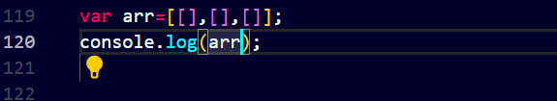

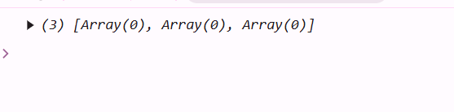

1. Declare and initialize a multidimensional array representing the following matrix:

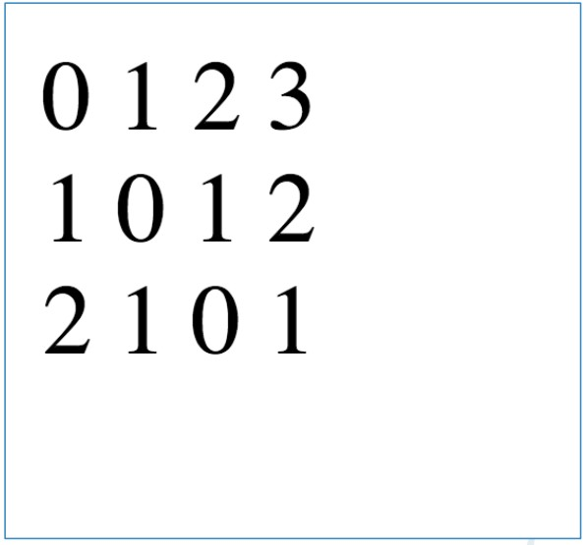

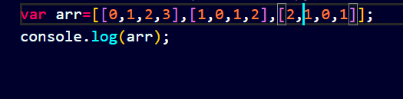

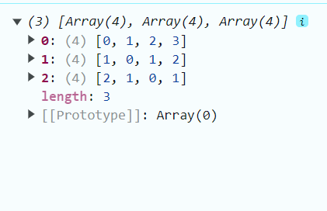

1. Write a program to print numeric counting from 1 to 10.

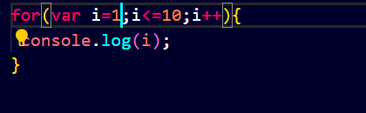

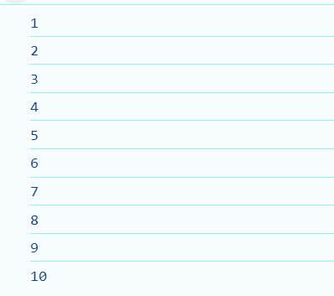

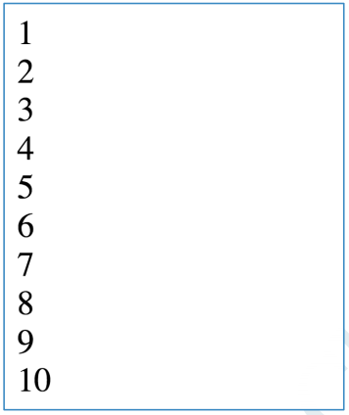

1.  Write a program to print multiplication table of any number using for loop. Table number & length should be taken as an input from user.

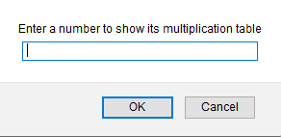



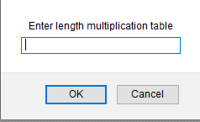

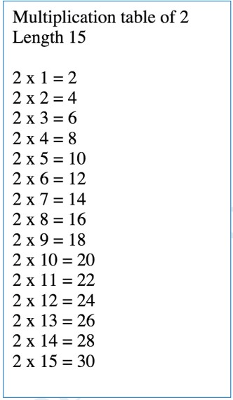

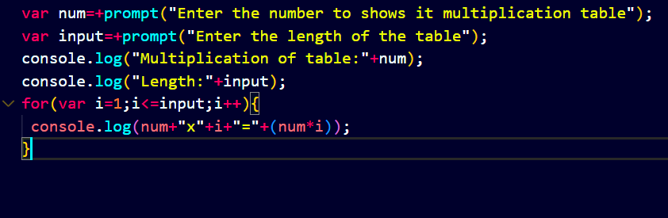

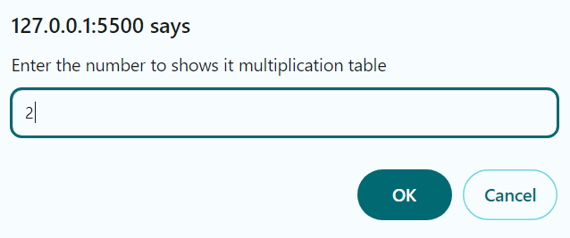

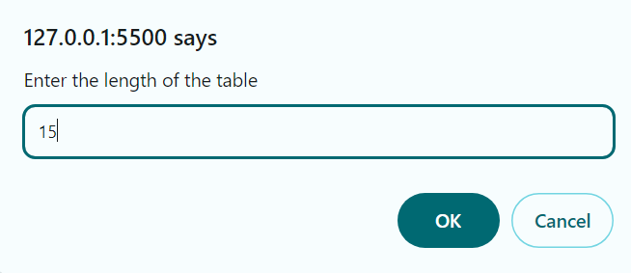

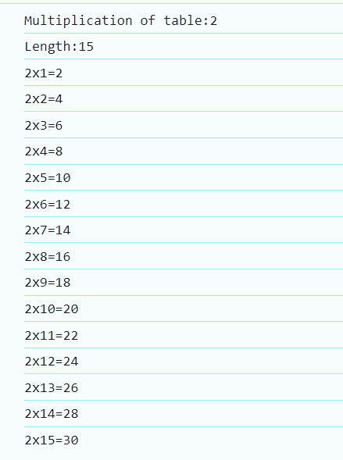

1. Write a program to print items of the following array using for loop:

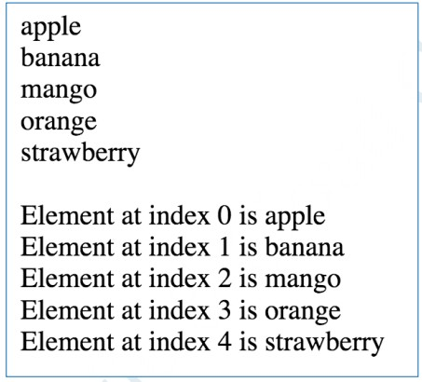fruits = [“apple”, “banana”, “mango”, “orange”, “strawberry”]

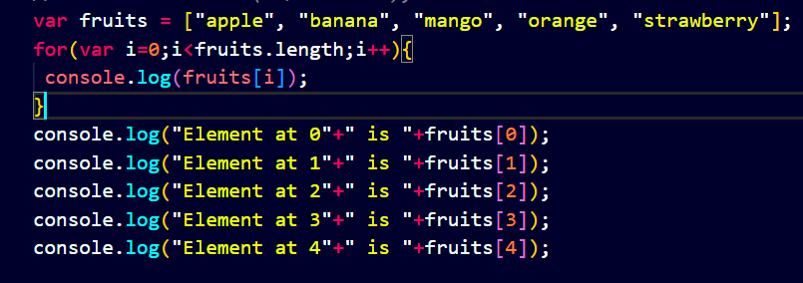

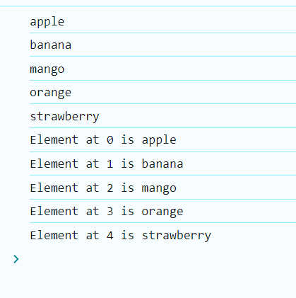

1. Generate the following series in your browser. See example output.

a. Counting: 1, 2, 3, 4, 5, 6, 7, 8, 9, 10, 11, 12, 13, 14, 15

b. Reverse counting: 10, 9, 8, 7, 6, 5, 4, 3, 2, 1

c. Even: 0, 2, 4, 6, 8, 10, 12, 14, 16, 18, 20

d. Odd: 1, 3, 5, 7, 9, 11, 13, 15, 17, 19

e. Series: 2k, 4k, 6k, 8k, 10k, 12k, 14k, 16k, 18k, 20k

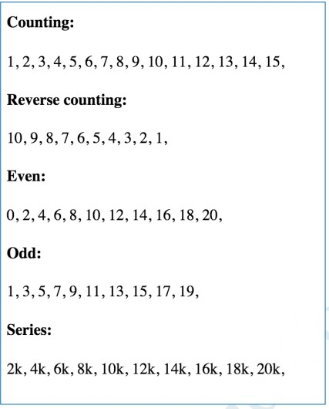

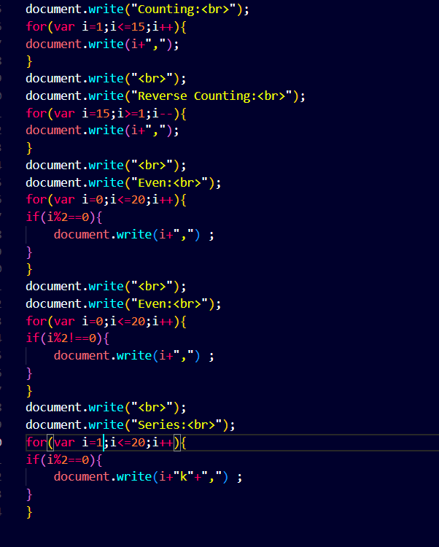

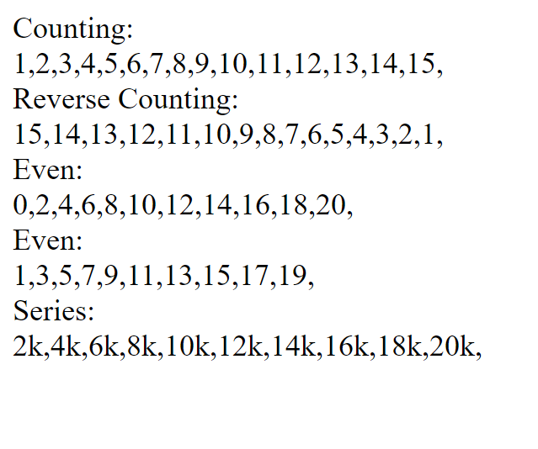

1. You have an array

A = [“cake”, “apple pie”, “cookie”, “chips”, “patties”] Write a program to enable “search by user input” in an array.

After searching, prompt the user whether the given item is found in the list or not. Example:

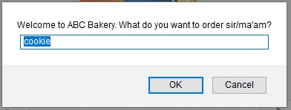

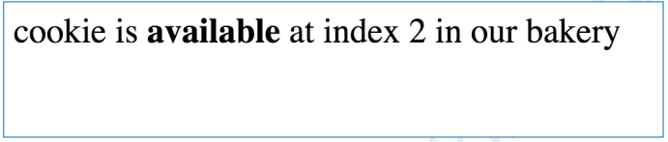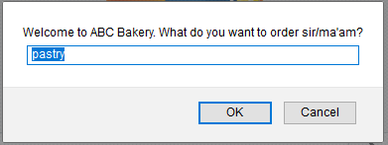

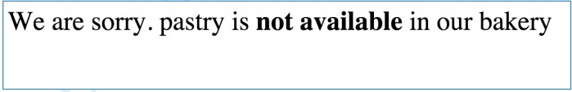

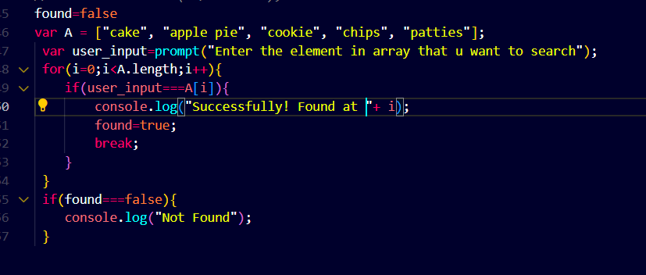

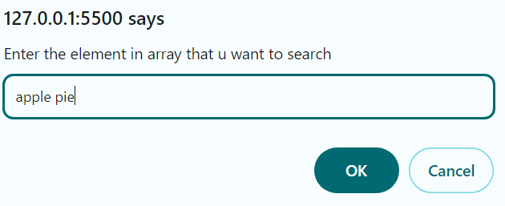

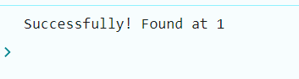

1. Write a program to identify the largest number in the given array.

A = [24, 53, 78, 91, 12].

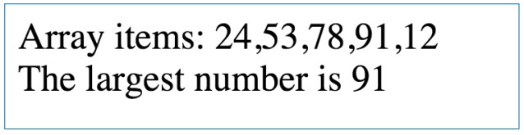

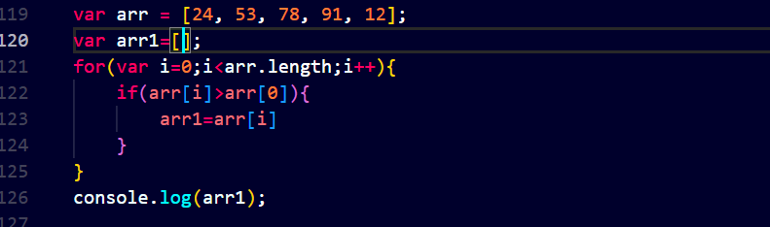

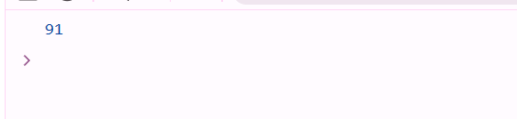

1. Write a program to identify the smallest number in the given array.

A = [24, 53, 78, 91, 12]

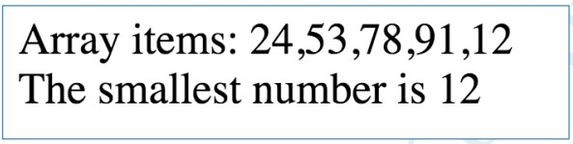

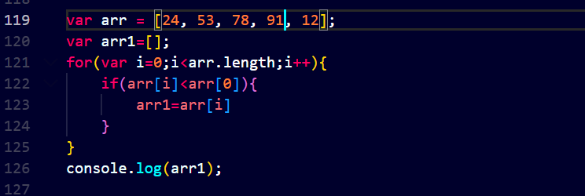

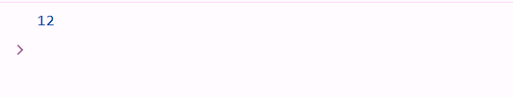

1. Write a program to print multiples of 5 ranging 1 to 100.

